Software Development with Java
Final Project
SDEV 200
Andrés Succar
Band Payouts
A Java-based app that calculates the splits between band members.
Screenshots and documentation
Figure 1. Adding members from the console menu: Jordan (Core, 30%) and Chris (Session, fee 120).
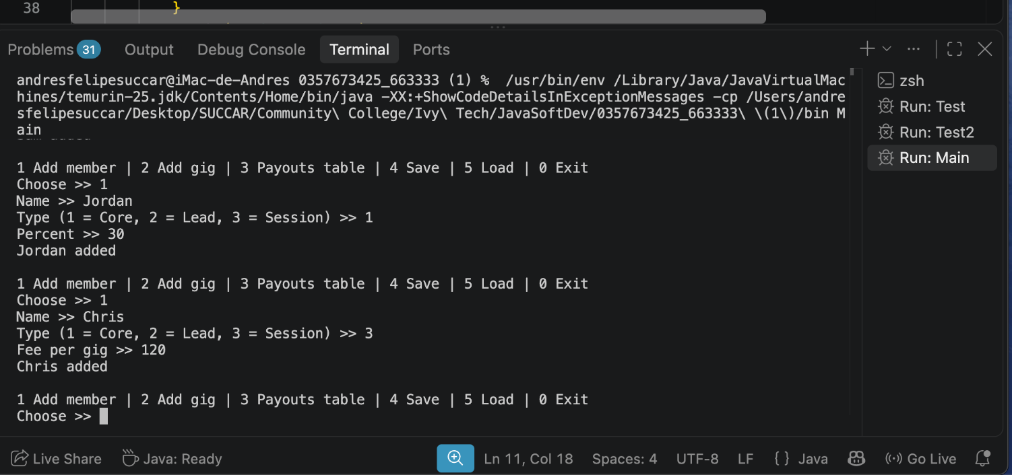
Figure 2. Adding two gigs: Blues Brothers Bar Friday (income 900, expenses 150) and Jazz Club Saturday (income 1200, expenses 200).
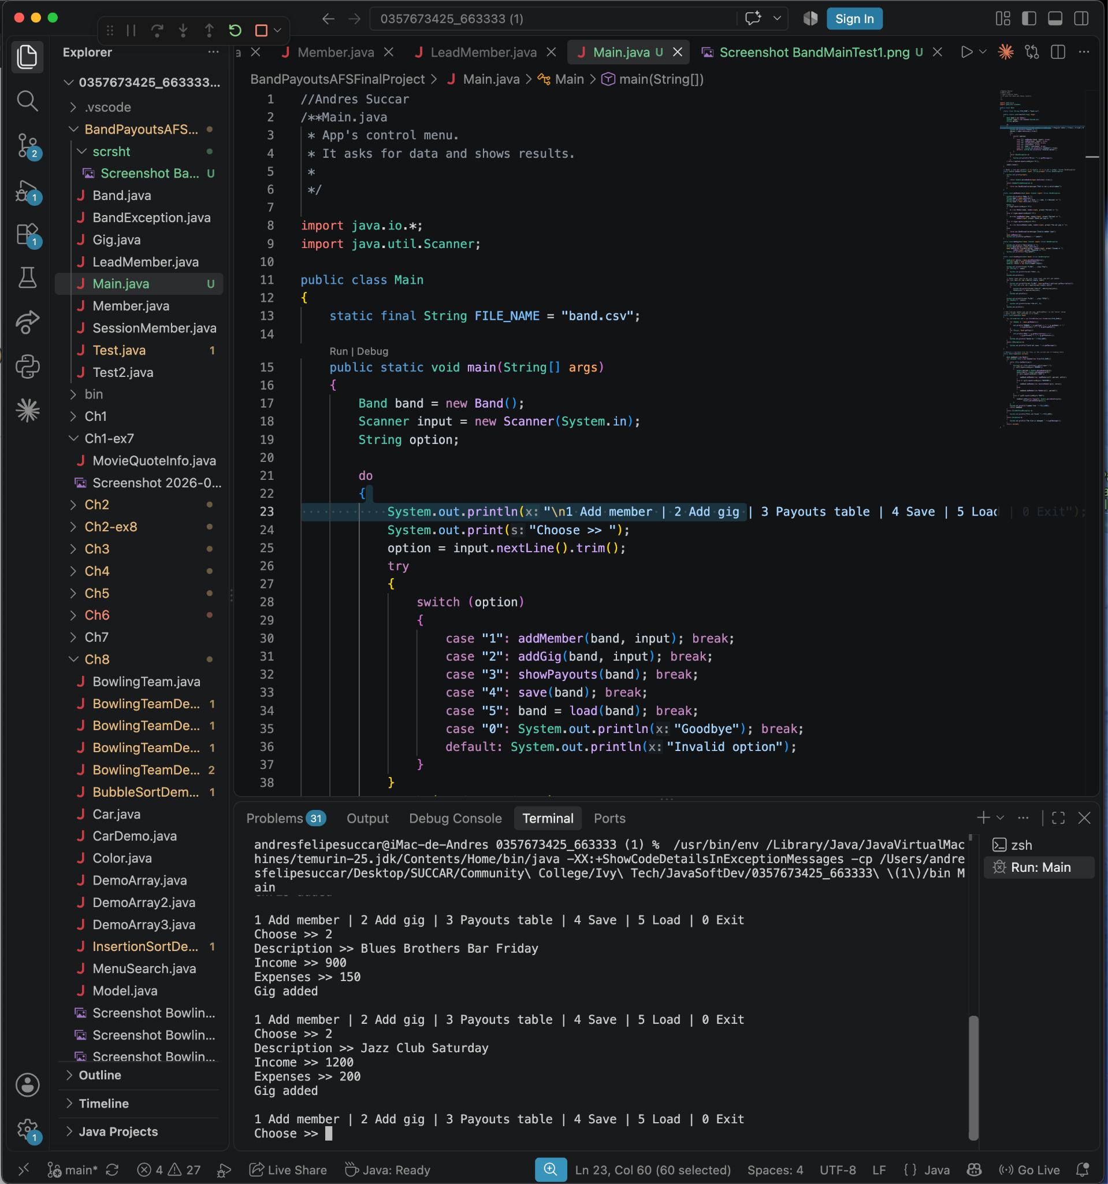

Figure 3. Payout table for the two gigs: 174.00, 282.00, 174.00 and 120.00 for the first gig, 249.00, 382.00, 249.00 and 120.00 for the second, and a TOTAL row of 423.00, 664.00, 423.00 and 240.00. The lines above show the Save message and a Load that reports “File not found”; the program keeps working.
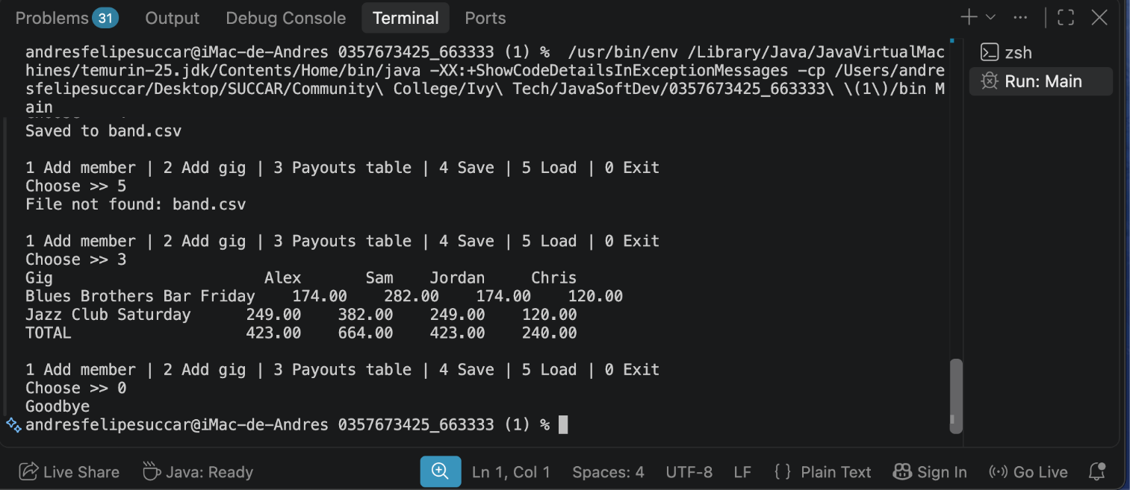

Figure 4. Error message when adding a member whose name already exists (Alex).
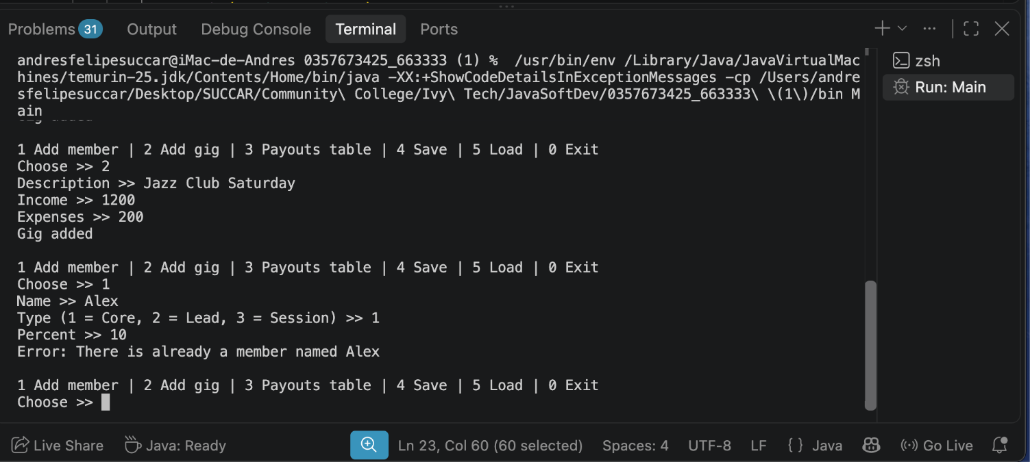

Figure 5. Error messages for invalid percentages: 150 is rejected as out of range, and the text “abc” is rejected as not a valid number.
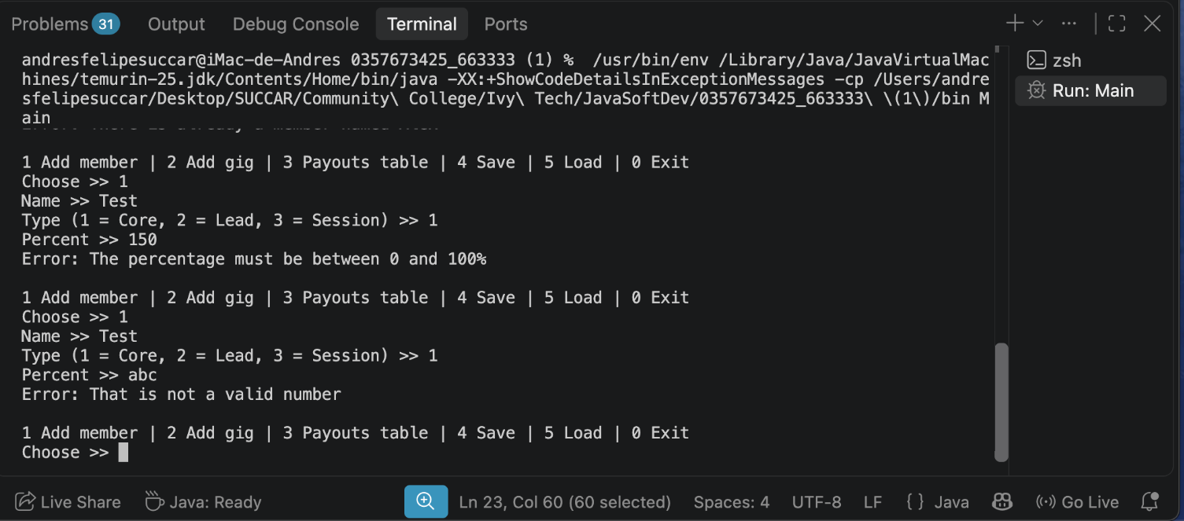

Figure 6. Error messages for a negative bonus (−5) and for an invalid member type (9).
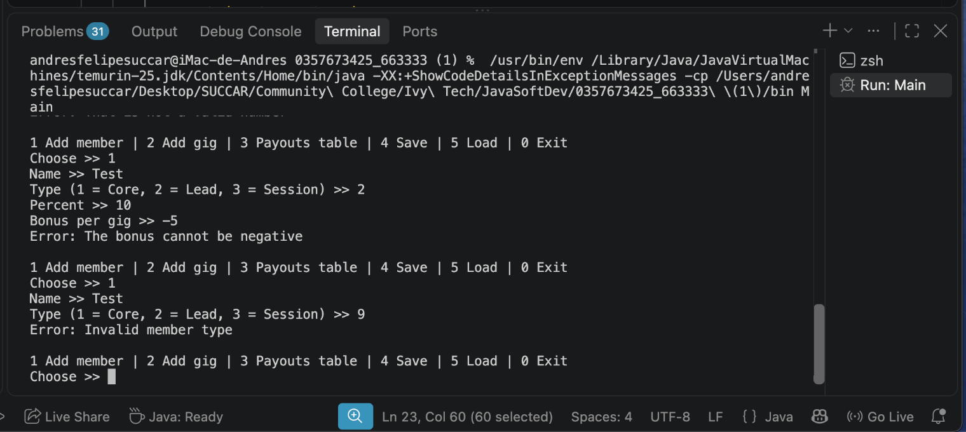

Figure 7. Error when the net of a gig (Open Mic, income 100) does not cover the fixed pay of the band.
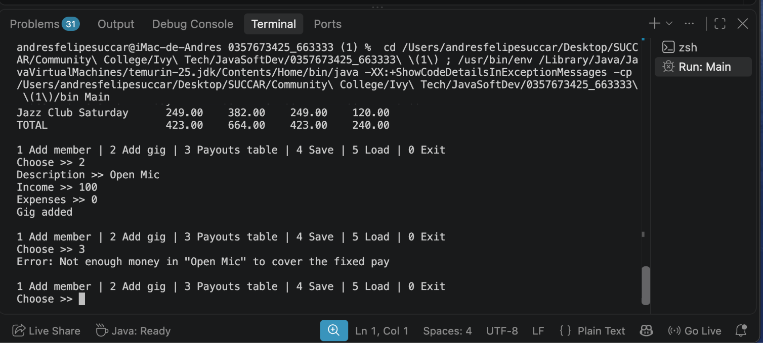
Figure 8. Error when the members’ percentages do not add up to 100 (now 30.0).
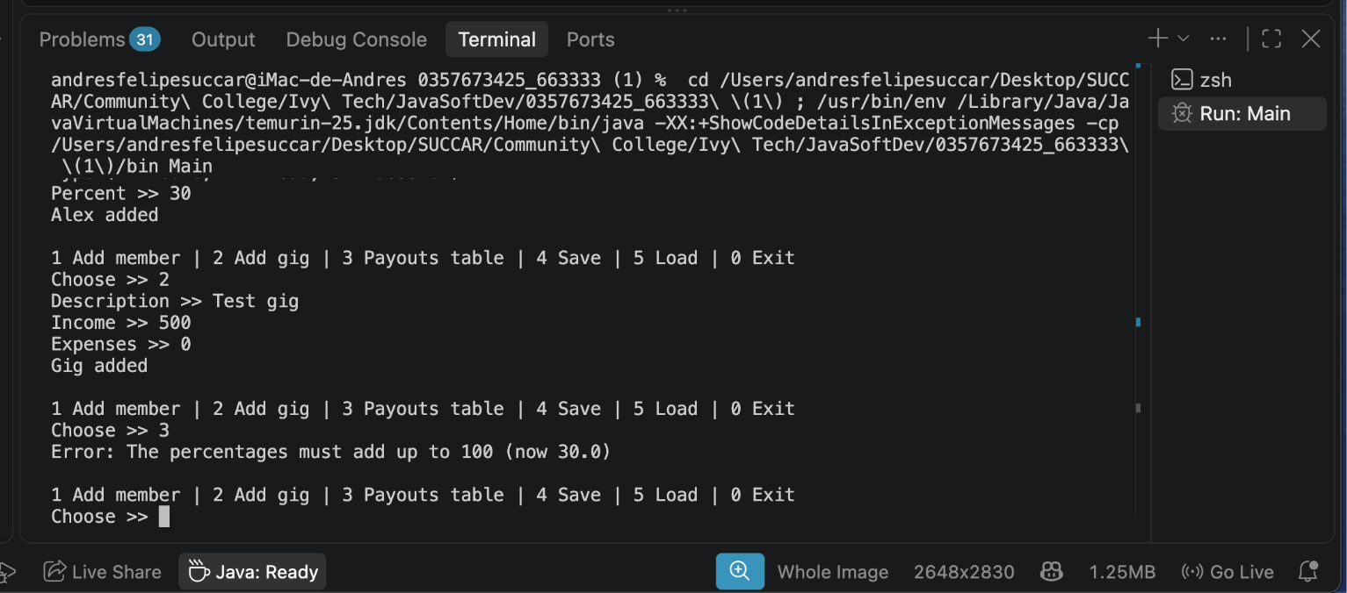

Figure 9. Error when the payout table is requested and the band has no members.
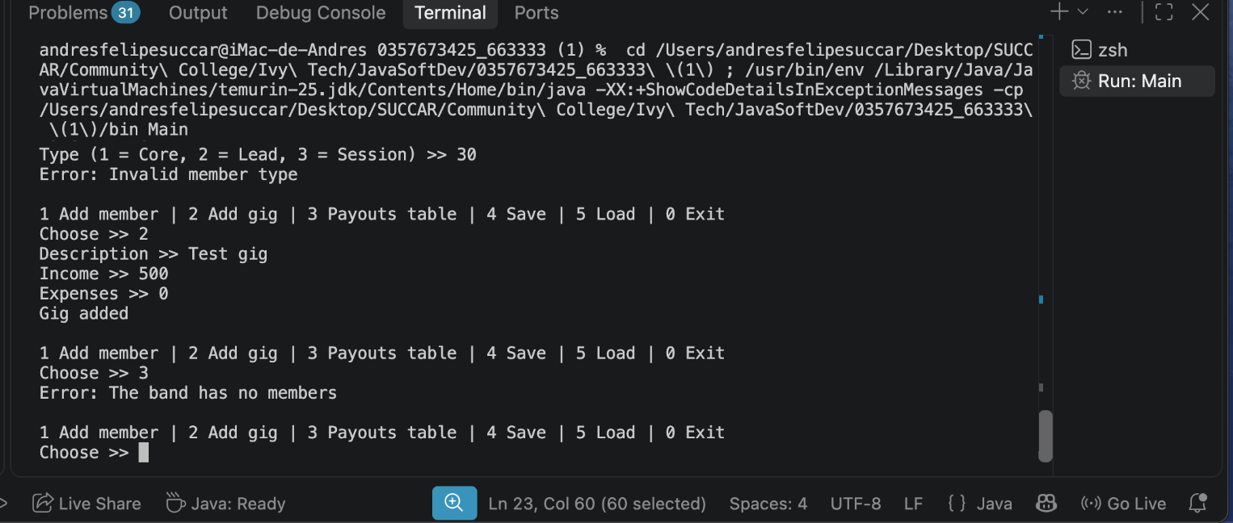
Figure 10. Option 4 saves the data (“Saved to band.csv”). The file contains one line per member and one line per gig.
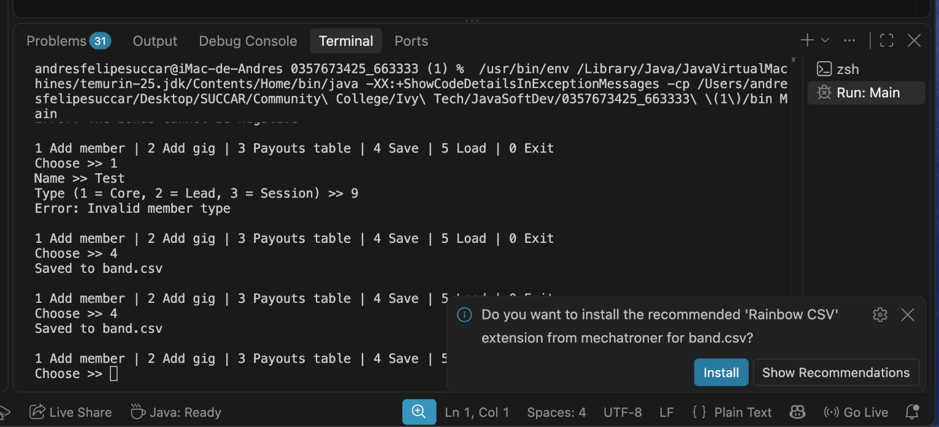

Figure 11. Option 5 when band.csv is not at the expected location: “File not found”. The program keeps running.
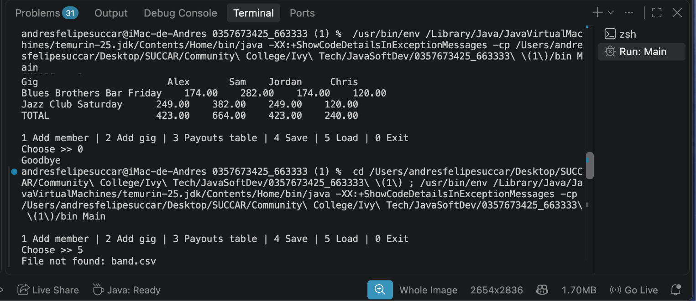
Figure 12. Gigs tab of the window
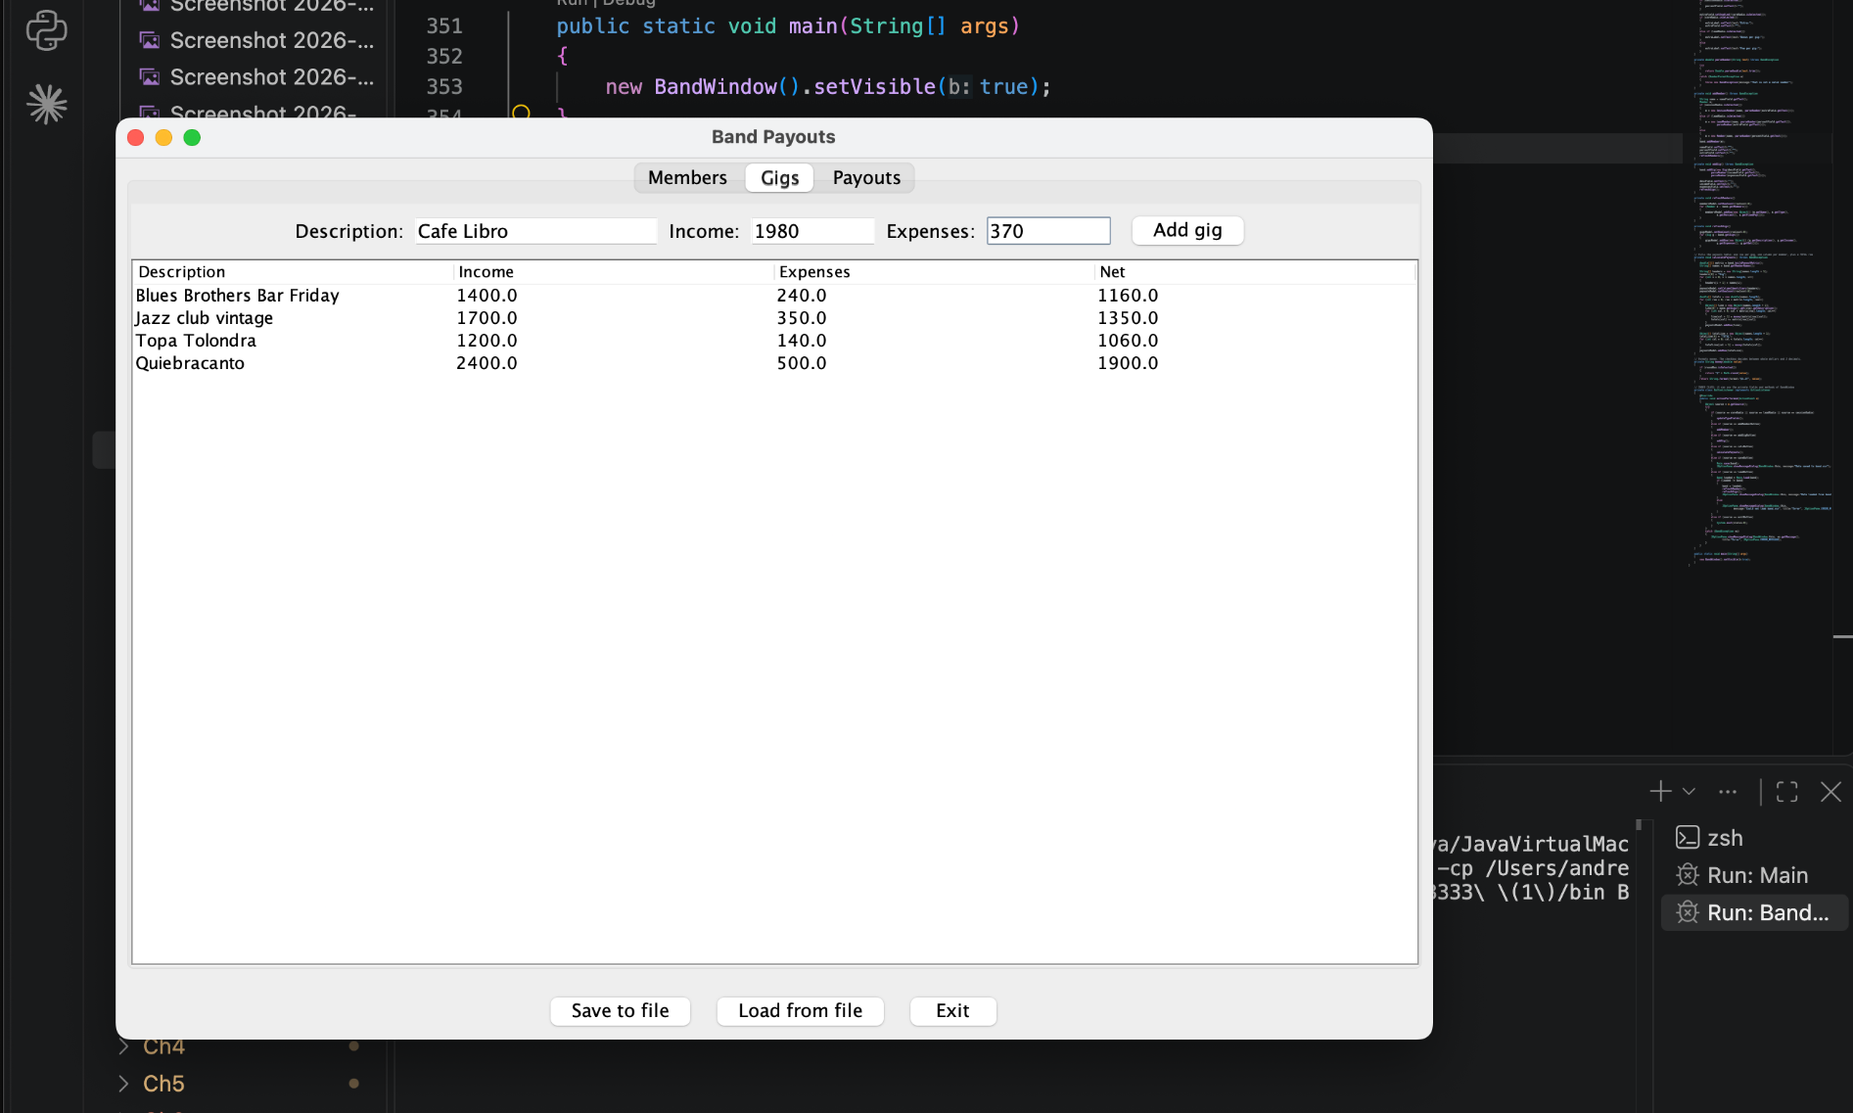

Figure 13. Payouts tab with a second data set (six members and five gigs): one row per gig, one column per member and a TOTAL row.
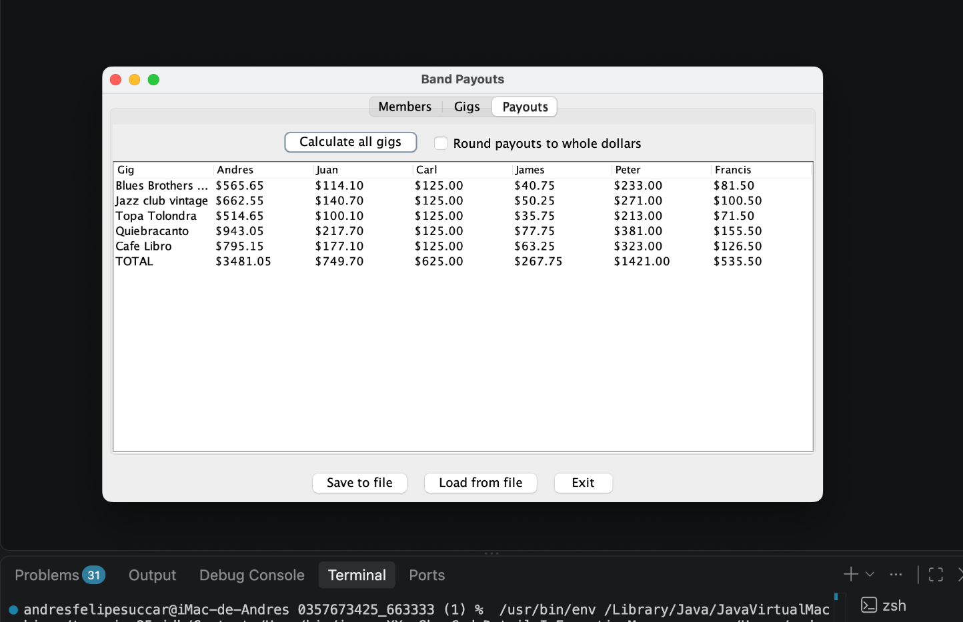
Figure 14.Gigs tab of the window with five gigs already added: Blues Brothers Bar Friday (income 1400, expenses 240), Jazz club vintage (1700, 350), Topa Tolondra (1200, 140), Quiebracanto (2400, 500) and Cafe Libro (1980, 370). The Net column is calculated automatically (1160, 1350, 1060, 1900 and 1610), and the Delete selected button removes the highlighted gig.
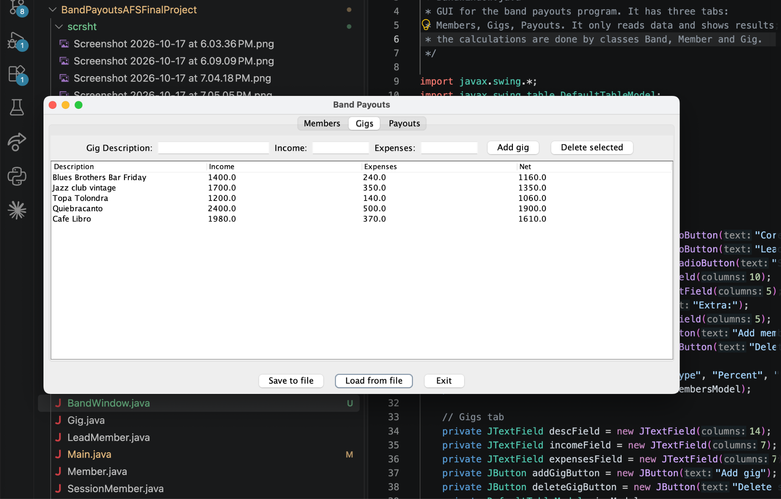

Figure 15: payouts tab of the window with six members (Andres, Juan, Carl, James, Peter and Francis) and the five gigs above. Each row is one gig and each column is one member. The TOTAL row adds each member’s column: 3481.05, 749.70, 625.00, 267.75, 1421.00 and 535.50, which together equal 7080.00, the sum of the five net profits. The rounding checkbox is cleared, so values show two decimals.

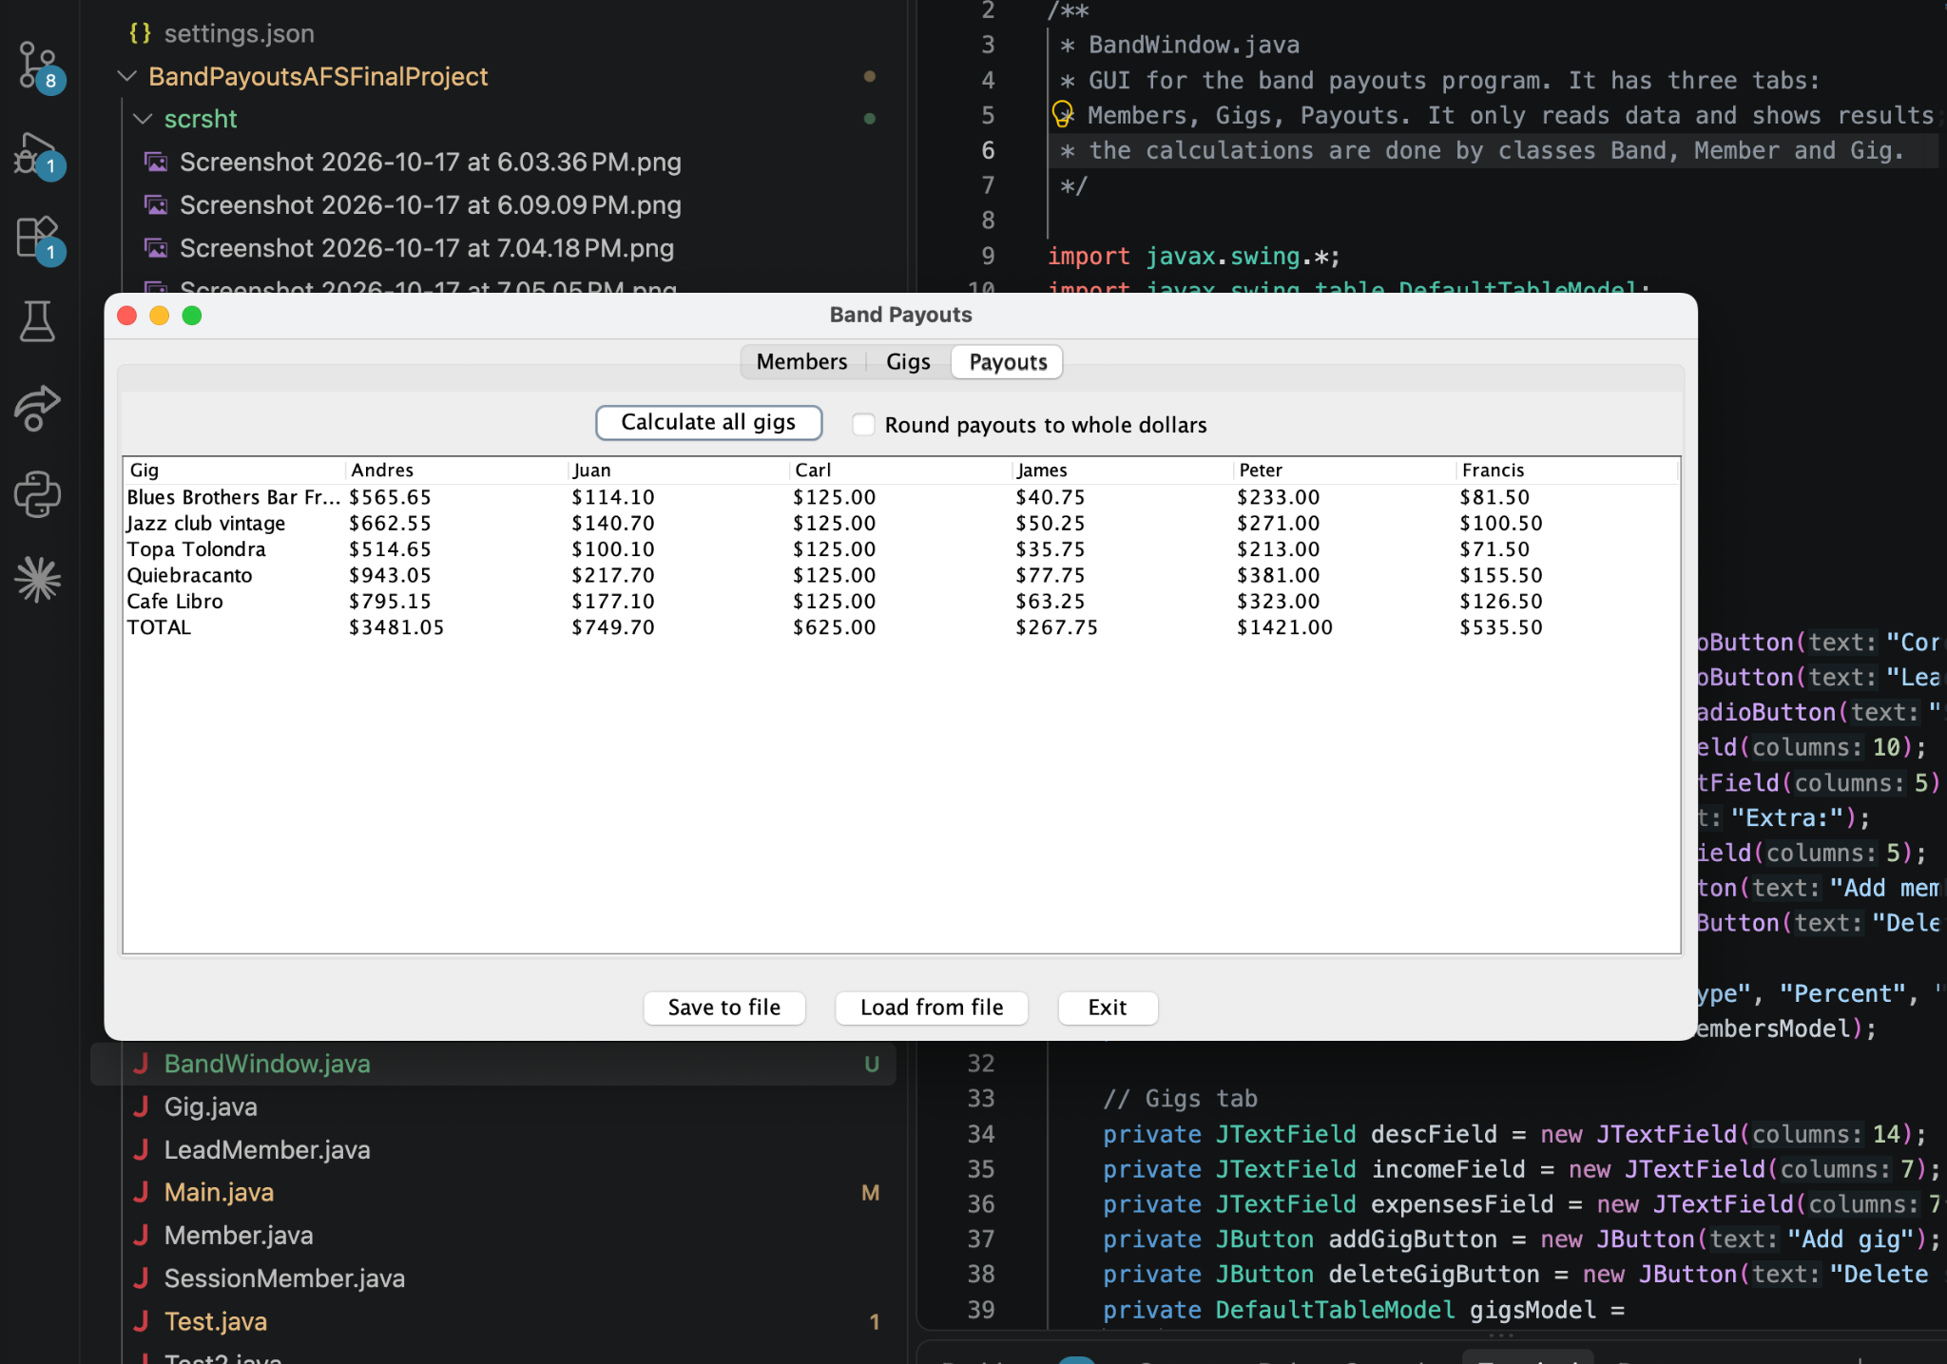

Figure 16. Error message when adding a member whose name already exists (Andres).
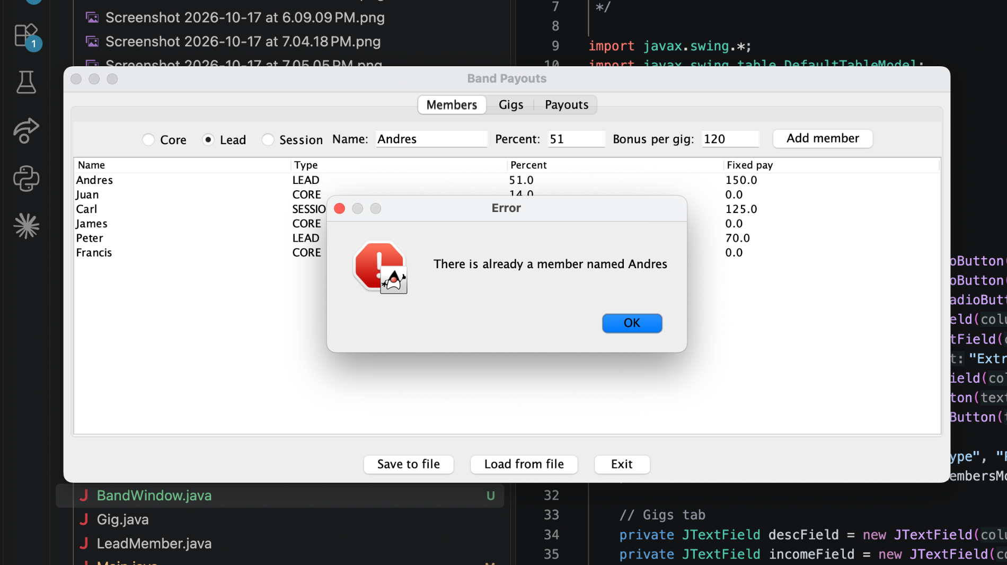
Figure 5. Error messages for invalid percentages: 150 is rejected as out of range.
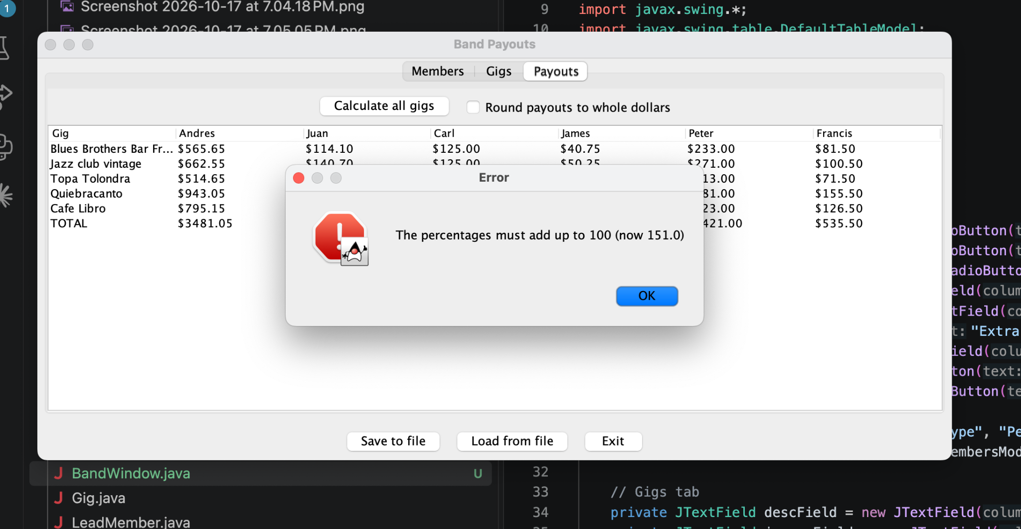

Figure 6. Error messages for a negative bonus (−5) and for an invalid member type (9).
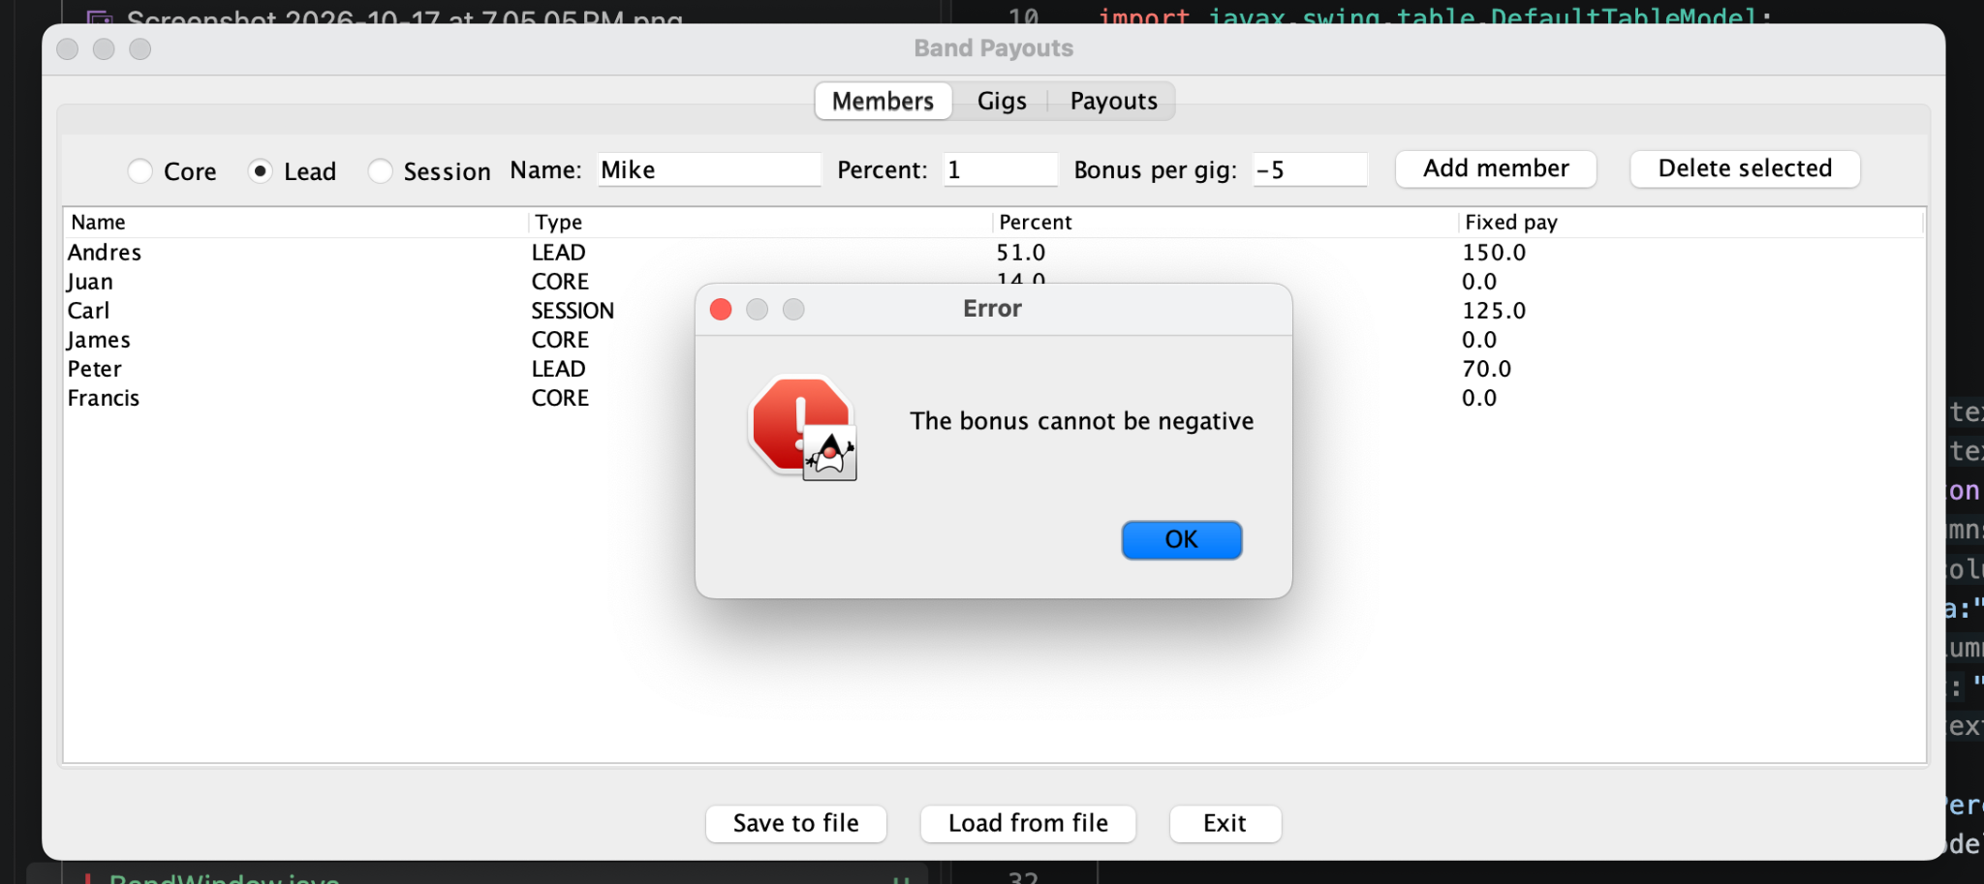

Figure 7. Error when the net of a gig (Open Mic, income 100) does not cover the fixed pay of the band.
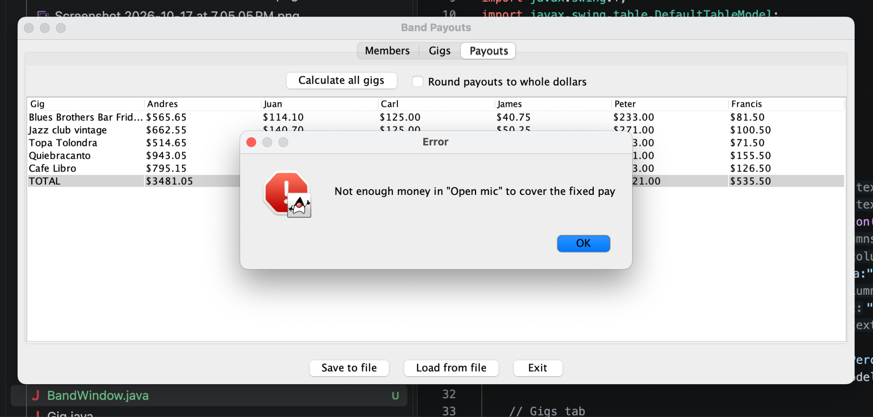

Figure 8. Error when the members’ percentages do not add up to 100 (now 70.0).
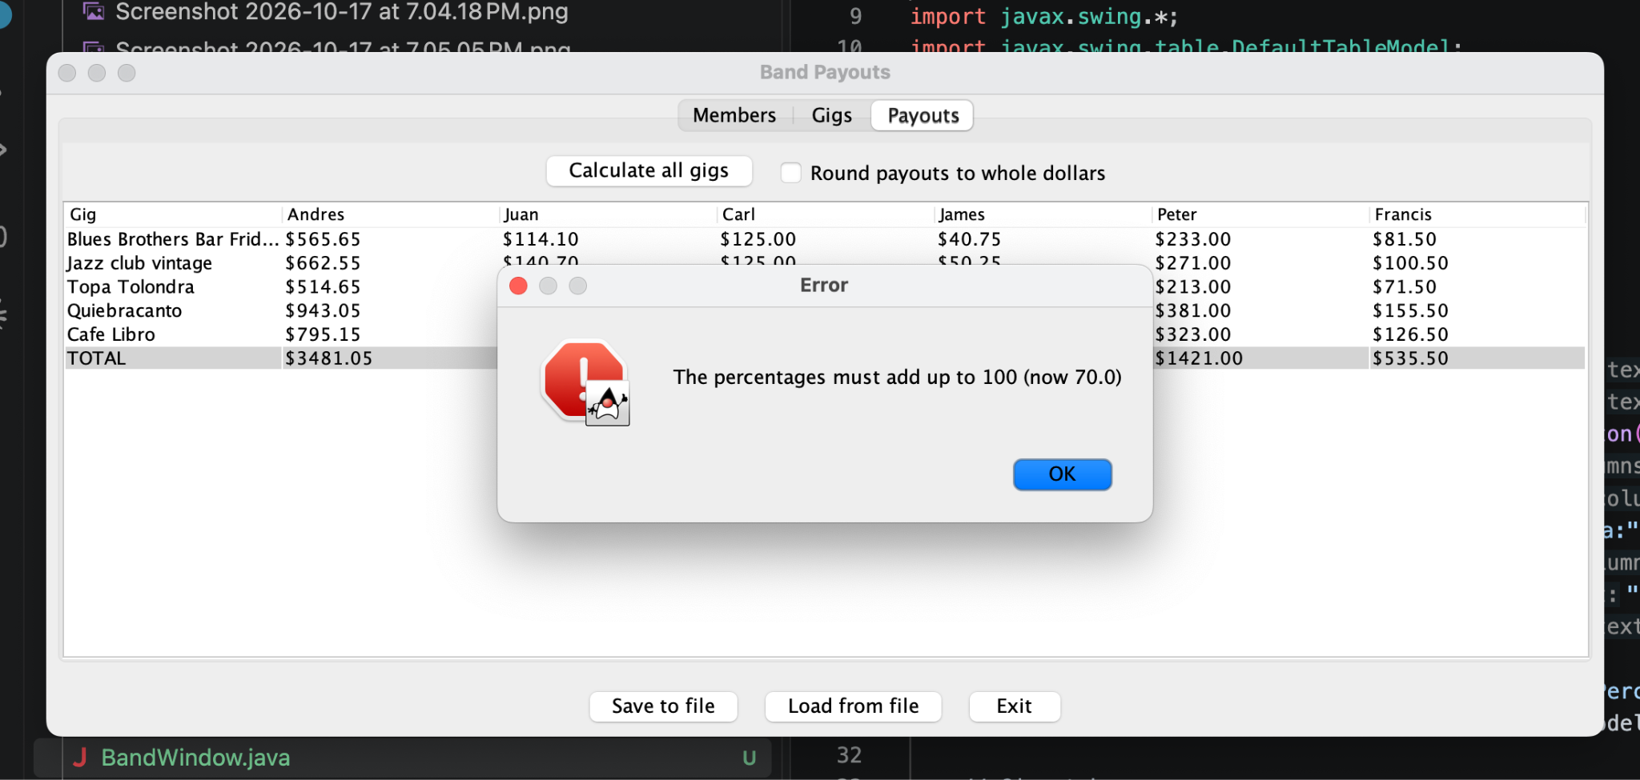

Figure 9. Error when the payout table is requested and the band has no members.
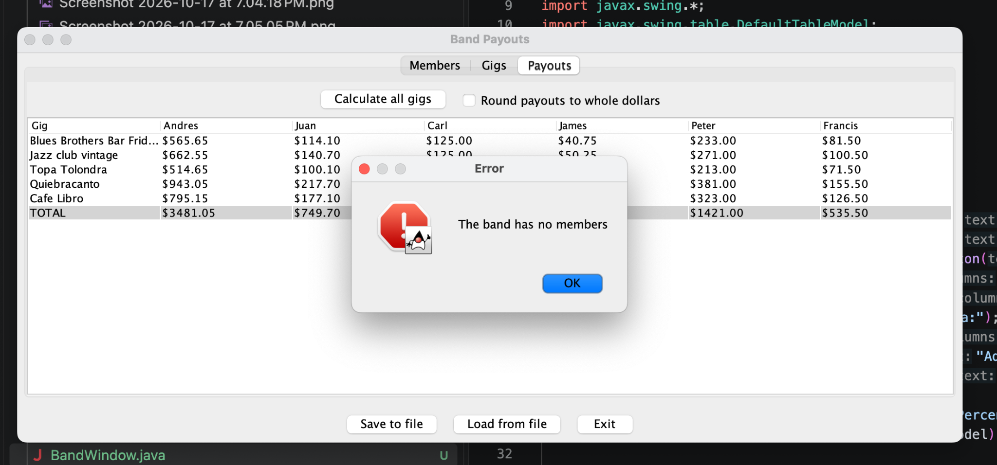

Figure 10. Option 4 saves the data (“Saved to band.csv”). The file contains one line per member and one line per gig.

